SFC simulation
Basic structural properties:
- Mimics ~ one hypercolumn with 40,000 excitatory neurons.
- Each pool in an SFC is 200 neurons wide
- Each neuron in pool i connects to all neurons in pool i+1.
- Each neuron participates in 25 pools (None of which are within the refractory period distance from each other.
Derived structural properties:
- Each neuron connects to 200x25= 5000 other excitatory neurons.
- Connectivity is 5000/40000 = 12.5%.
- Altogether there are 40000*25/200 = 5000 pools. These may be organized in any way into chains (E.g. 100 chains each 50 pools long).
Dynamic properties
- The delay from middle of volley in pool i to the middle of the volley in pool i+1 is 3 ms.
- Mean firing rate is 5/s.
Derived dynamic properties
- Alltogether 5x40000 = 200,000 spikes/s.
- For each 3 ms there are 200000*0.003 = 600 spikes
- These can support 600.200 =3 simultaneous waves.
Inhibition
?? tbd
Initially brutal: One Mega-Inhibition: Measure histogram of membrane potentials (without spikes) of all 40,000 excitatory neurons and set the threshold such that only 600 of them will fire. [Problem: 600 neurons should fire within one delay of transmission from pool to pool (~3 ms), but simulation steps are much shorter].

Programming with minimal memory requirements
For each SFC pool which neurons take part in it 5000*200 = 1,000,000 values
For each neuron:
- List of SFC pools it participates - 25 variables
- List of times it fired in the last 100 ms (expected 0.1*5 = 0.5), up to 5 times
- Its membrane potential in the last 5 (?) steps 5 variables.
- Its conductivity for Na and K - 2 variables
- Current derived from its synaptic inputs – 1 variable
Total: 38 variables
Total for all the network 38*40000 <160,000
Grand total for the entire network 1,160,000

Updating the status of a neuron
(Updating is in parallel with a small time step say 0.1 ms)
- Find which neurons serve as its input
- For each of them find if fired in the past 1 ms and compute the synaptic current it contributes.
- Add some random noise
- Add external inputs (to simulate activation of a SFC from outside).
- Update the membrane potential.
- Update Na + K conductivities.
Repeat for all neurons
For model 0 inhibition (see above); Find the new threshold
For each neuron decide if it fired, if so add to its firing list and update Na and K conductivity.

Efficient synaptic currents.
The shape of the EPSC is given by
Thus if we define q₁ and q₂ such that they correspond to 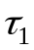 and 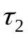with step size δ then:
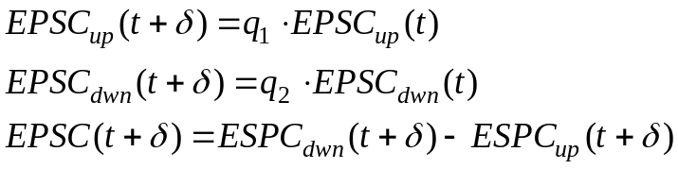
When a presynaptic spike arrives at the postsynaptic neuron both EPSC_{dwn} and EPSC^{up} are increased by Amp.

Note: In this mechanism the spike does not reset the synaptic currents but just increase K conductivity, which in turn will make the synaptic currents less efficient.

Updating one neuron.
When updating a single neuron, follow the formula:
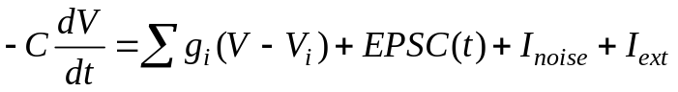,
where I_{ext} is the external input which the simulation dictates; I_{noise} is given by:
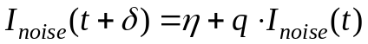,
where q represent the noise time constant and η is the random noise. Its variance will be 0.5/(1-q). The sum is over all ionic currents (here Na, K, Cl).

When V reaches threshold the neuron fires:
- V is reset to V₀.
- g_{k} increases a lot.
- The index of the updated neurons is entered into the list of firing neurons.
- 1 is added to the queue of delays for that neuron.
- The queue of delays is forwarded by one. If a spike arrives at delay 0, all the post synaptic EPSC are updated by Amp. [Note that there will be a slight difference between the synaptic currents of neurons that were updated before the current one and those updated after it.]
- g_{i} return towards their steady state values with time constants q_{i}.

Time Considerations
Stage 1 above can be computed from the tables of which neuron takes part in what pool, and which pool takes part in what chain. This will have to be repeated for every neuron in every time step of the simulation. Thus that will be the bottleneck for computations. In MATLAB on my PC it took between 165 and 231 seconds for finding the connections of all 40,000 neurons. This is unpractical!

A solution is to prepare a table of connections between neurons:
40,000x5000x2 = 400,000,000 bytes, which on the edge of what can be done in MATLAB on Windows.

Design of synfire chains
How to design a SFC where each neuron takes part in multiple pools and several waves can be operating simultaneously with no confusion.
Parameters:
N – number of neurons in the net (e.g. 20000)
W – width of each pool (e.g. 50)
P – number of pools(e.g. 1600). Note that these may be concatenated into one long SFC or organized in mant sorter SFCs it does not matter.
For normalization we consider the peak amplitude of an EPSP as 1.
T – The integration time of an EPSP (e.g. 8 ms).
D – The delay in progression from one pool to the next (e.g. 3 ms).
K – The number of waves running simultaneously in the SFCs (e.g. 8).
Derived values:
M – Mean number of pools in which each neuron takes part is given by:
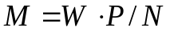 (e.g. 50*1600/20000=4)
k – Number of neurons active within the integration time of the EPSP.
s – Number of synaptic contacts made by k neurons.
q – number of random synaptic activation per neuron as generated by s synapses.

The relations among all these parameters should be such that the number of EPSPs, which are unrelated to the wave that each neuron receives within T, will be much less then W.
Within T there will be k neurons active.
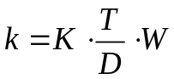 (e.g. 8*8/3*50 = 1066)
The number of EPSPs (s) that these k neurons will generate is:
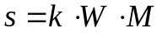 (e.g. 1066*50*4 = 213200)
These are distributed at random among N neurons. Thus every neuron is expected to randomly integrate q EPSPs. For stability q must be much smaller then W:
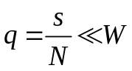 (e.g. 213200/20000=10.6 << 50)

If there is also background noise with variance of σ², then threshold should be between q+3σ and W-3σ.

Increasing K or M can be done by:
- Increasing N (the network size).
- Increasing D (the delay from one pool to the other).
- Decreasing T (EPSP time span)
- Decreasing W (how many neurons in a pool). However this is limited by the level of noise in the background.

Note that in all the arithmetic above there is no inhibition!

